Revolutionises how applications are built through the usage of containerization technology.
Containers:
- Lightweight portable units to run applications.
-Bundles applications with all it’s components to run efficiently.
-Containers contain code, libraries and all dependencies.
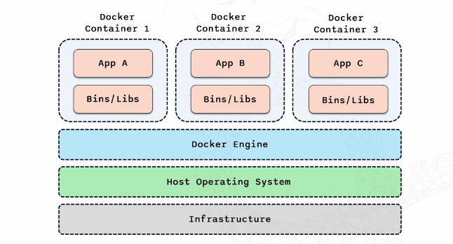
Benefits of Containers:
-Isolated- Avoids conflict and ensures app runs smoothly as each container holds the dependencies for a specific app.
-Runs on all devices
-More resource efficient as they share the host kernel which reduces overhead and allows for multiple containers to run.
Docker:
-Open platform for developing, shipping and running applications in containers.
- Makes it easy to smoothly run applications.
Core tools:
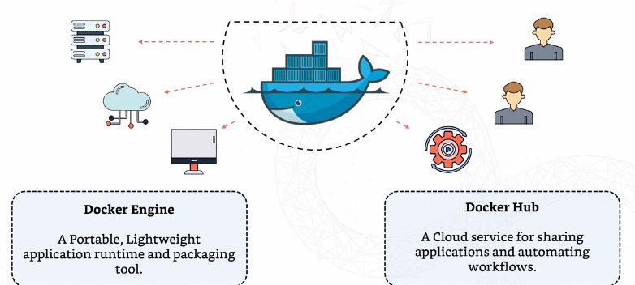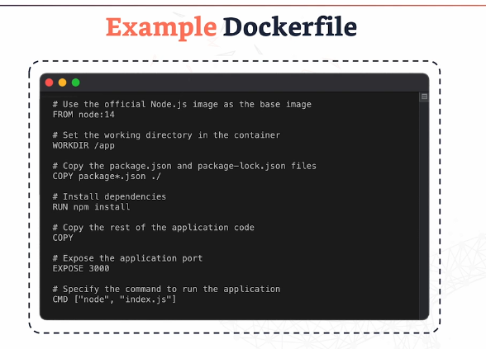
Importance in Modern Development
- Simplified Deployment
- Improved efficiency. Traditional VM’s can be heavy and slow, whereas containers are quick to start and lightweight.
- Enhanced Collaboration.
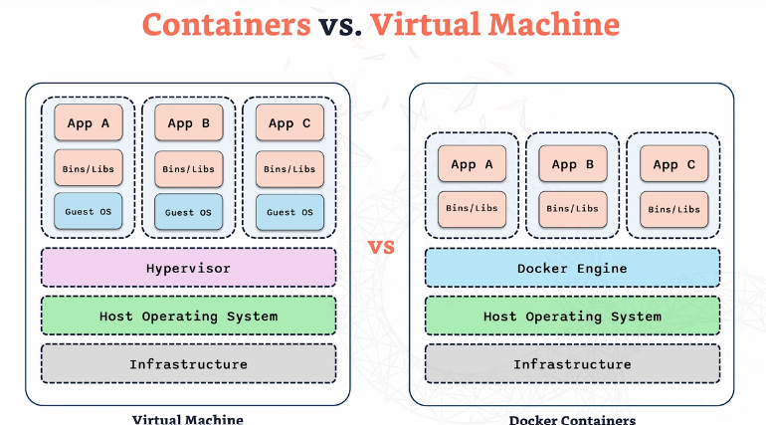
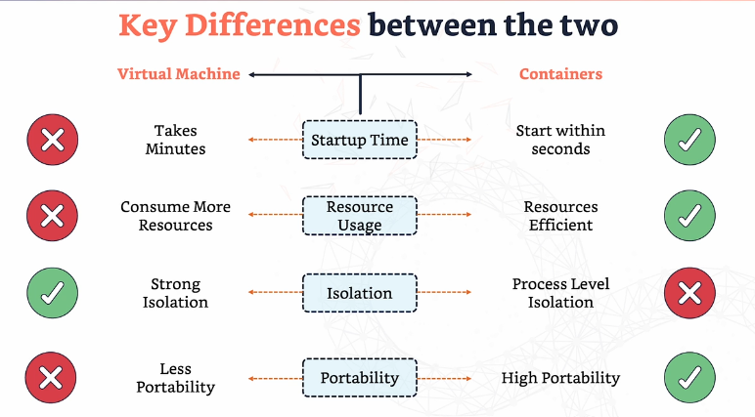
Dockerfile:
-Recipe for creating your containerised application.
- Recipe on creating docker image.
- Allows for repeat builds.
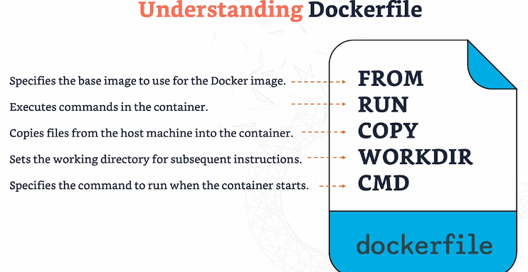
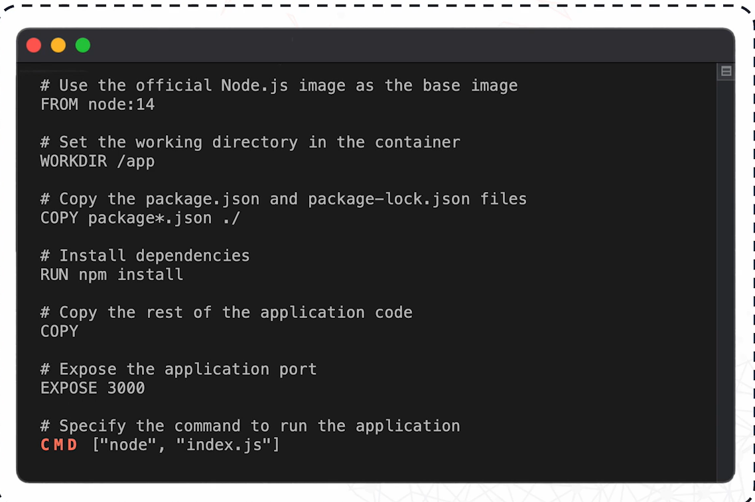
Steps required to install flask on VSCode using python:
1. Install the required packages
sudo apt update
sudo apt install python3-venv python3-full
2. Go to your project
cd /mnt/c/Users/ahmad/OneDrive/Desktop/Docker-notes/hello_flask
3. Create a virtual environment
python3 -m venv .venv
4. Activate it
source .venv/bin/activate
Your prompt should change to something like:
(.venv) jahmad@JubzLaptop:~/...
5. Install Flask
pip install flask
Now it should install without the "externally-managed-environment" error.
6. Run your app
python app.py
or
python3 app.py
Networking concepts in Docker-
Bridge- Default. Connected to bridge network and connect to each other through different ip addresses.
Host- Container uses host machine directly with no distinction between container and host. Useful for close interactions.
None- Used to ensure a container has no network access at all.
Docker compose:
Powerful way to manage multiple containers at once.
-Tool that defines and managers multiple containers.
-Define all services in one file.
-Docker compose yml file is a blueprint that describes each container. Defining everything on this file allows to spin up a complete environment with one command.
-Docker-compose up to create details within the file.
-Allows for containers to communicate with each other seamlessly.
Why is Docker compose important in DevOps:
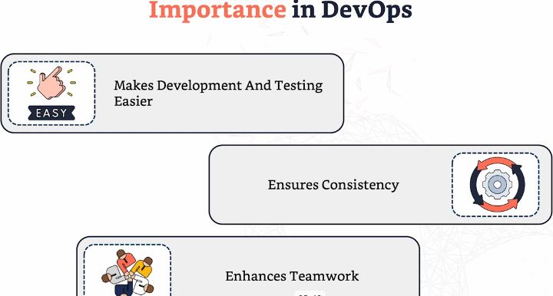

Docker Registries
-Storage and distribution hub for Docker images. An online library.
There are: Public registries and Private registries
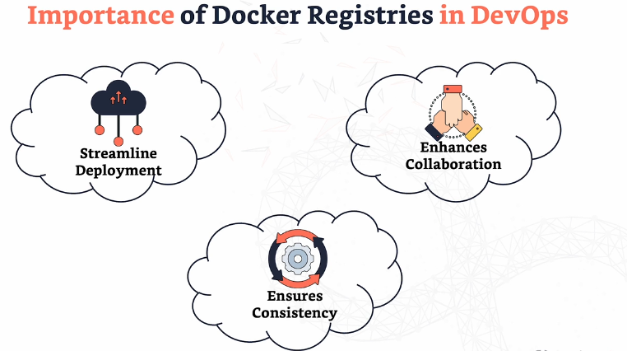
Docker Hub- Most popular Docker registry. Public. Store, share and access images.

Important Docker Commands to know:

Docker images- Showcases all the images you have and it’s details. Useful to keep in track on which images are available and for clean up purposes.
Docker inspect followed by image id- Shows comprehensive information and details about an image.
Docker rmi followed by image id- Removes the docker image in order to save space.
Docker system prune- Used to removed unused images, containers, networks and more. Great for a bulk clean up.
Docker stop- Stop containers that are running.
Docker rm- Completely removes containers. Great for freeing up resources.
Multi stage builds: Allows multiple From statements. Use one stage to build an app and another stage to actually deploy. This approach allows to remove unnecessary files and dependencies, resulting in a smaller more optimal image.

